1. VACCINIA VIRUS

* Discovery Date: In 1796, the British doctor Edward Jenner proved that an infection with the relatively mild cowpox virus would also confer immunity to the deadly smallpox. Jenner referred to cowpox as variolae vaccinae (smallpox of the cow).
* Data: By October 9, 2023, the world has recorded 90,618 cases of Monkeypox( caused by Vaccinia Virus) in 115 countries around the world, including 157 deaths; The global average number of cases per week is nearly 200 cases/week. Most cases are concentrated in the Americas and Europe. In Southeast Asia alone, a total of 427 cases have been recorded to date, mainly recorded in Thailand (399); There are 25 countries recording new cases within the last 21 days (as of September 26, 2023). 96.3% of cases are male, average age is 34 years old. Most cases have heterosexual orientation (96%), of which homosexual men account for 83.2%, bisexual men 7.4%; The most common route of transmission is through sexual contact (51%); 52.7% of cases have HIV.
* Structure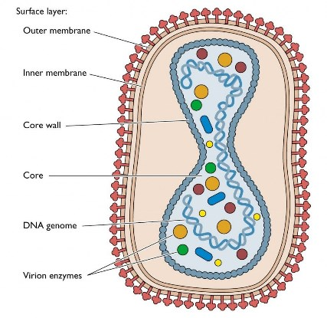
* How does Vaccinia Virus infect a cell: <https://www.youtube.com/watch?v=QHHrph7zDLw>

**KEY FACT**

**Vaccinia is used to generate live recombinant vaccines for the treatment of other illnesses. Modified versions of vaccinia virus have been developed for use as recombinant vaccines. The modified Ankara strain (MVA) of vaccinia virus was developed by repeated passage in a line of chick embryo fibroblasts. NYVAC is another attenuated form of the vaccinia virus that has been used in the** **construction** **of live vaccines. NYVAC has a deletion of 18 vaccinia virus genes that render it less pathogenic**.